4G Body camera user manual
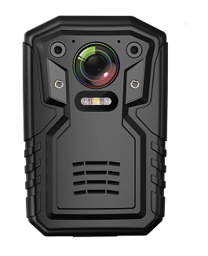

V1.0

Sound light

the ©2017

All rights reserved.

Without the written permission of the Company, no unit or individual may extract or reproduce any part or all of the contents of this book, nor shall it be disseminated in any form.

The contents of this manual will not be updated periodically due to product version upgrades or other reasons. Unless otherwise agreed, this manual is intended for use only, and all statements, information and recommendations in this manual shall not constitute any express or implied warranty.
Catalogue
Version note 5

Introduction to this book .................................................................................................................5

1.1 Product overview .....................................................................................................................7

1.2 Product specification.............................................................................................................. ..9

1.3 Product Application................................................................................................................ 10

2 Host Operations Guide .............................................................................................................11

2.1 introduction to the machine and keys.................................................................................... 11

2.2 Switchgear............................................................................................................................. 13

2.3 Video recording .....................................................................................................................14

2.4 recording ...............................................................................................................................14

2.5 Photography.......................................................................................................................... 15

2.6 playback................................................................................................................................ 15

2.6.1 Video playback ...................................................................................................................15

2.6.2 recording playback ..............................................................................................................16

2.6.3 Photo playback ...................................................................................................................18

2.7 setup ......................................................................................................................................19

2.7.1 Video resolution ..................................................................................................................20

2.7.2 Video code rate................................................................................................................... 20

2.7.3 Transmission resolution...................................................................................................... 20

2.7.4 Net-borne frame rate ...........................................................................................................20

2.7.5 Transmission rate ...............................................................................................................20

2.7.6 Video mode ..........................................................................................20

2.7.7 Bad coverage...................................................................................................................... 20

2.7.8 Video subparagraph............................................................................................................ 21

2.7.9 Video prescreen...................................................................................................................21

2.7 . 10 Photo size .......................................................................................................................21

2.7.11 Photo quality..................................................................................................................... 21

2.7.12 Photo mode .......................................................................................................................21

2.7.13 number of consecutive photographs................................................................................. 21

2.7.14 Photo intervals.................................................................................................................. 21

2.7.15 automatic switchboard...................................................................................................... 21

2.7.16 automatic shutdown ..........................................................................................................21

2.7.17 loudspeakers..................................................................................................................... 21

2.7.18 Voice broadcast ................................................................................................................21

2.7.19 Infrared switching.............................................................................................................. 22

2.7.20 Guang Min Induction......................................................................................................... 22

2.7.21 4G switch ..........................................................................................................................22

2.7.22 WIFI switch .......................................................................................................................22

2.7.23 WIFI hot spot..................................................................................................................... 22

2.7.24 resumed factory setting..................................................................................................... 22

2.7.25 language selection............................................................................................................ 22

2.8 system information................................................................................................................. 23

2.8.1 Central Information .............................................................................................................23

2.8.2 4G status

2.8.3 GPS status ..........................................................................................................................24

2.8.4 WIFI status ..........................................................................................................................24

2.8.5 equipment information........................................................................................................ 24

3. Product installation

3.1 packing list .............................................................................................................................25

3.2 equipment upgrade ................................................................................................................25
Former speech
imprint

This manual corresponds to the product version is: KJ01 high definition Body Camera user manual V1.0.

Introduction to this book

This manual introduces a 4G high-definition body camera product, describes the appearance of the equipment, operating interface and user operation in detail.

The book is divided into four chapters.

Chapter 1. Product specification introduction.
Chapter 2. The host operation guide. Detailed description of the various settings and parameters in the host menu, as well as the corresponding configuration interface.
Chapter 3. Installation of equipment. Mainly introduces equipment packing list and subsequent upgrade maintenance.
Chapter 4. Installation and use of Management Software for Body Camera
Attention to the principle of complete observance and presentation

Before installing and using this product, be sure to read the following warning:
Read this manual. Safe storage
This manual is for future reference.
1. Please take it lightly during transportation.
2. All installation and maintenance must be performed by professionally trained qualified persons.
3.To avoid overheating, keep the recorder ventilated smoothly.
4. If the recorder has smoke, smell, or murmur, please turn off the power immediately and unplug the power cord, and contact the supplier in time.
5. If the recorder is not working properly, please contact the supplier who purchased the recorder and do not disassemble or modify the recorder in any way.
6. do not charge at high temperature. The overheating of the battery may cause an explosion, and the high temperature refers to not more than 45 degrees.
7. Read the user manual carefully before using the equipment, follow the operation instructions strictly.
8.Please do not knock or collide with this product at will to avoid product damage or data loss.
9. Do not use the equipment in excess of the standard wet or high temperature environment, avoid the use of the equipment in the vicinity of strong interference sources and shielding equipment.
10. To avoid the loss of equipment content, please backup the datain time after using this product.
11. Please keep the front lens clean so as not to affect the camera or video.
12. Avoid placing equipment in direct sunlight, poorly ventilated areas, or near heat sources such as heaters or heaters (ignoring this may lead to fire hazards).
13.Please take good care of your user name and password.
14. No module shall be replaced when the mainframe is live.

1. Product specification

The main features of the Body Camera: video recording, video capture, wifi link, 4G real-time upload. Its main functions are listed in the table.
specification
basic configuration | Sensor | OV4689
 | Slug | Amba A12 chip
 | display screen | 2.0寸（5.2cm ）
 | camera lens | 150 °very wide angle
 | levels of protection | IP66
 | Fall grade | 2M
 | LCD display screen | Highlight display screen
 | locate function | Built-in GPS positioning module, real-time positioning
 | TF card | 32GB/64GB/128G。
 | WIFI function | Support for 802.11 b/g/n protocol 2.4GHz
 | 4G network | TD-SCDMA / EVDO / WCDMA / LTE-TDD FDD
image parameter | Output pixel | 32M
 | Shutter control mode | electronic shutter
 | Focusing mode | F.NO=3.2 150度
 | Focusing distance | 50cm- infinity
 | Exposure mode | voluntarily
 | Photo file format | JPEG
Video&Audio  parameter | Resolution | 1080P/720P/VGA
 | Frame rate | 1080p@30fps/720p@30fps
 | Quality | High / medium / low setup
 | Video Compression Standard | H.264 high profile
 | Video compression format | MP4
 | Audio compression standard | G711/ADPCM/AAC
 | Audio input | High quality microphone
 | Continuous recording time | Video 8 hours, 4G Internet 4.5 hours)
 | Storable recording time (32G) | About 190 hours
size | Volume (mm) | 96*62*34mm
 | weight | about 195g
power | Battery capacity | about 3600mAh
 | charging time | About 4 hours
 | stand-by time | More than 170 hours
 | Charging mode | USB charging / data acquisition station charging
Auxiliary light source | Infrared complementary lamp | support
 | Bright LED white light | support
 | Laser positioning | support
Other parameters | Log function | support
 | watermark | Device ID, Constable ID, time and date
 | Infrared switching mode | Photoresistor automatic switch / manual switch
 | Language | Chinese / English
 | Interface | Mini USB/30 Pin
 | LED indicator lamp | Charge indication, video, recording, online
appendix | user's manual | instructions
 | clamp | 360 degree rotating back clip
 | Data line | Mini USB
 | adapter | 5V/2A
work environment | working temperature | -20℃～+60℃
 | Storage temperature | -40℃～+70℃
 | Working humidity | 40％--90％
Accessory | Base charger | standard configuration
 | Vehicle charger | optional
 | Bluetooth function | optional
 | External camera | optional
 | Assembled shoulder clip | optional
software | Management software | Green professional PC end management software
 | Operating system | Windows XP /Win 7/Win 8/Win 10

1.1 Product application

The 4G high-definition Body Camera is a highly integrated device specially developed for the law enforcement industry. The equipment supports photo taking, video recording, recording, local storage, infrared night vision, laser positioning and 3G / 4G wireless transmission. Video can be uploaded directly to the background through 4G or 3G or WIFI or AP network environment. Users can view the video returned from the front end through mobile phone PC client. Is the scene law enforcement good helper.

Host operations guide
Introduction to the keys of the whole machine

Key instruction
Key name | icon | method | function
Power key |  | Short press | On / off screen  In the shutdown state, no effect.
 |  | Long press | A long press of 3 seconds can turn on / off the machine.
Intercom key |  | Long press | Activate the intercom.
Video key |  | Short press | In boot state, short press video recording, again short press stop recording; shut down state, short press boot and turn on video recording
 |  | Long press | Same as short click function
Photo key |  | Short press | Under standby condition, the photo can be taken after pressing. During video recording, the photo can be captured and saved
 |  | Long press | In any state, the white light can be turned on by a length of 2 seconds, and the white light can be turned off again by a long time of 2 seconds.
Recording key |  | Short press | Audio recordings can be made in standby state, again press will stop recording and automatically save
laser  infrared |  | Short press | Under the condition of turning on, laser position shooting can be carried out after pressing to ensure that the picture is not biased
 |  | Long press | In the state of boot, the long press can be switched to the infrared mode at night, which can be used for video or photo shooting
Multifunctional interface |  | connect | Expansion of second channel camera
SIM | SIM | socket | Insert SIM mobile phone traffic card to realize real-time transmission function
HDMI | HDMI | connect | Connect high-definition display, high-definition output interface
USB | USB | connect | Data transfer interface
Menu key |  | Short press | In standby state, press this button to enter menu settings;  Returns to the preview state under the information display menu;
Upward key |  | Short press | In the menu setting or file selection state, for upward flipping function;  In the preview state, enter the message display menu; press again for the upturn function
Down key |  | Short press | In the menu settings or file selection state, the down flip function  In the preview state, enter the message display menu; press again for the down flip function
Return native playback |  | Short press | In the menu setting or file selection state, the short click to return to the next level;  Returns to the preview state under the information display menu;  In preview state, click enter local playback menu, select playback video, photos, audio files
Alarm key |  | Short press | Trigger alarm video, record 30 seconds, and report the alarm to the center and upload the alarm video to the central platform at the same time
 |  | Long press | In the video state or playback state, identify the current video file as an alarm video

State description
Working light status explanation
Indicator state | State description
green | idle
red | picture recording
orange | sound recording

Interface icon description
Flag name | Definite meaning
 | Video recording long press alarm key, recording key document logo;
 | Turn on the GPS, indicating that the GPS signal is successfully located;
 | Turn on 4G function, indicating that the device acquires 4G signal, and the grid indicates that the signal intensity is the strongest. The symbol indicates that 4G module is normal and no SIM card is inserted.
 | Turn on the WIFI function, indicating that the device successfully connected WiFi, display signal intensity of 4 arcs signal strongest; belt! Number indicates that the WIFI module is normal and not connected to the hot spot;
 | Represents the current amount of electricity left on the device;
 | Indicates that the device is in the video ;
 | Indicates that the device is connected to the platform;
13.7G/14.5G | The first half indicates that the device is currently available memory capacity  The second half represents the total memory capacity of the device;
2017/01/01 04:24:51 | Represents the current date and time of the device;
0000000_000000 | Indicates equipment ID _ Police number;
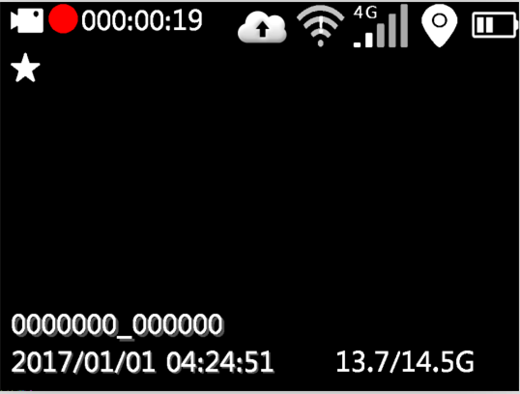

Switch machine

Long press law enforcement instrument "power key" 3 seconds, machine power on; in any state long press "power key" 3 seconds, machine shutdown; on state, short press "power key", can turn on / off screen.

picture recording
After the machine is turned on, the machine directly enters the preview state, presses "the video key" to record, the machine short vibrates two times, the top red indicator light long bright, in the recording state, again presses "the video key", the machine short vibration two times is accompanied by the buzzer prompt, End and save the video file.

In the shutdown state, short press the "video key", with boot function.

When shooting at night without light, you need to press the "infrared key". At this time, the infrared light is turned on to the night shooting mode, and the night photo is black and white.

sound recording
After the machine is turned on, the machine directly enters the preview state, press "recording key" to start recording, machine short vibration two times, the top yellow indicator light is always on, on the machine screen prompt has the recording status picture, Press the recording button again in the recording state to finish and save the recording file.
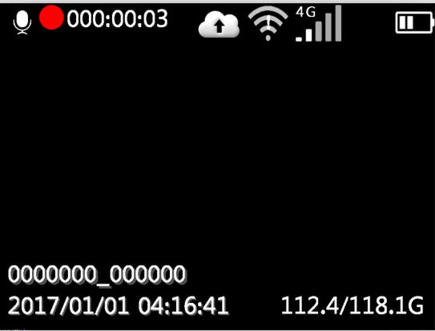

One key switch

After booting up, press the recording key when recording, you can save the current video file and start recording; when you press the recording key, you can save the recording file at that time and start recording.

take a picture
After booting the machine, directly into the preview mode, press the "camera" to take pictures, no light conditions under the night shooting needs to open or open automatically machine or infrared lamp lights were filmed. In the video or audio state, press the camera button can also take pictures;

playback
Press "return key", enter the playback menu, press "up and down" to choose to play video, photos and audio folder, press "confirm" to open the appropriate directory folder.

Video playback
Video directory is divided into multiple time period folder, press "confirm key" to open the folder, which is divided into a number of files shot in this period, press "confirm key" to play video, video file format for MP4.

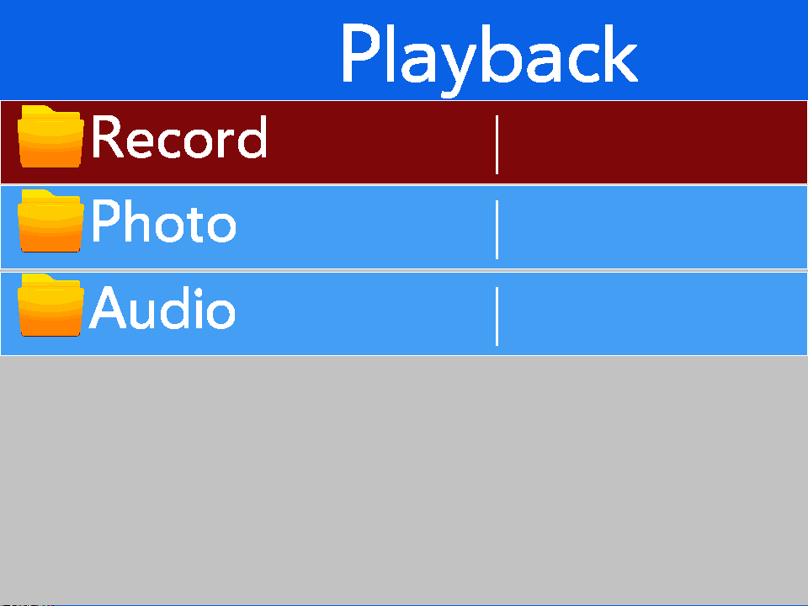
Figure 1 playback menu

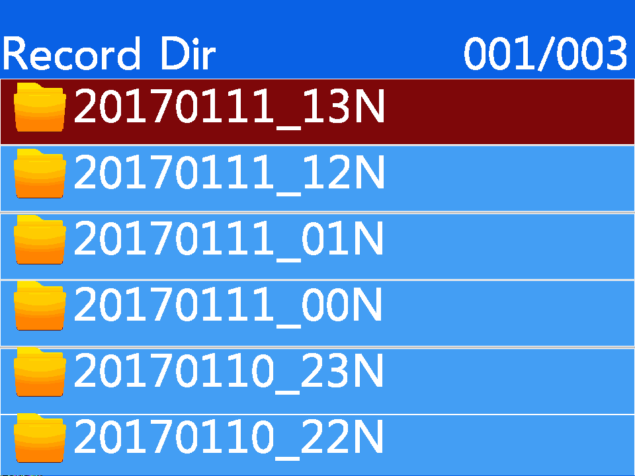

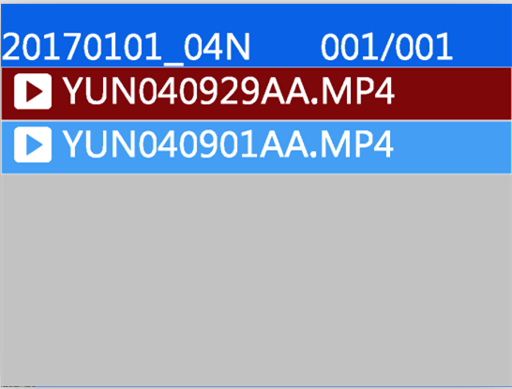

Recording playback
Recording directory is divided into multiple time period folder, press "confirm key" to open a folder, which is divided into a number of files shot in this period, press "confirm key" playback recording, recording file format for AAC.
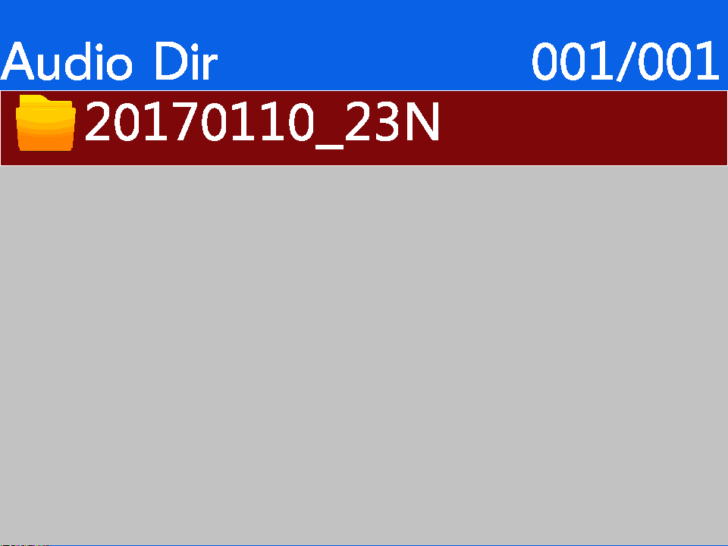

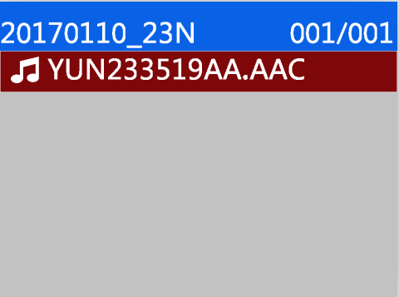

Photo playback
Photo directory is divided into multiple time period folder, press "confirm key" to open a folder, which is divided into a number of files taken in this period, press "confirm key" to view the photos, the format of the photo file is jpg.
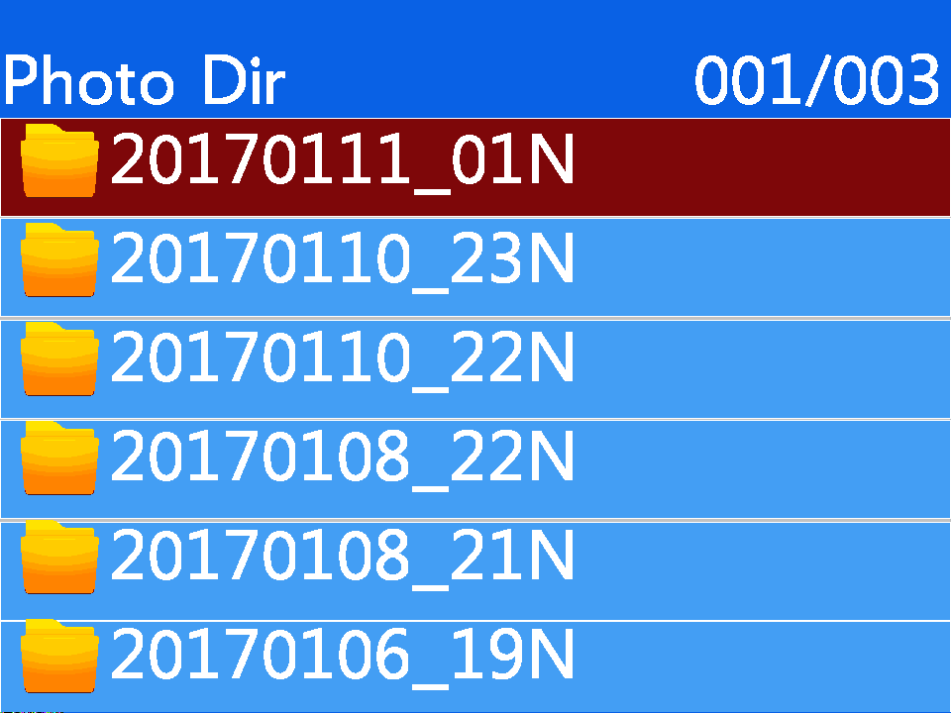

set up
After boot, in standby state, press "menu key", enter the parameter setting interface, select the parameter option that needs to be modified, press "confirm key" to enter this option, press "up, down key" to select the appropriate parameter, When you select confirm, press confirm. Press up, down to modify other options. Press return to return to standby preview.

Video resolution
Video resolution for local video storage, can choose 1296 PU 1080PU 720P, default 1080P (1920X 1080).
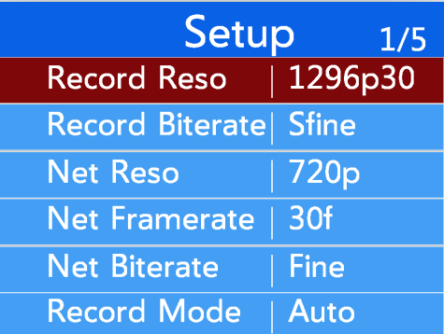

Video code rate
Setting the parameters of video recording , the higher the relevant parameter values , the clearer the picture quality , the smoother the video . The video setting parameters are as follows :
●Video resolution: 1296P30 1080P30 720P30

● Video bit rate: low / medium / high

Transmission resolution
Network resolution is used over 4G or WIFI networks

Image resolution for remote transmission, default 720p,

You can select 720P 1280X 720) and VGA 640X 480.

Network frame rate
Net-borne frame rate is used to set the number of image sheets per second for network transmission in the range of 30 / 25 / 20 / 15 / 10 / 5, by default30 frames per second.

Network transmission rate
The network transmission rate is used to set the network data volume per second, which is divided into three levels: high, medium and low. The corresponding code rate is as follows:

Network transmission rate | high | middle | low
720P | 1.8M | 1.0M | 800K
VGA | 1M | 700K | 350K

Video mode
Video mode supports boot and manual video.

Cyclic coverage
If the TF card is full, it will stop recording. (by default, when the memory is full, when the memory is full, the video will be automatically overwritten. Tagged focus files will not be overwritten)

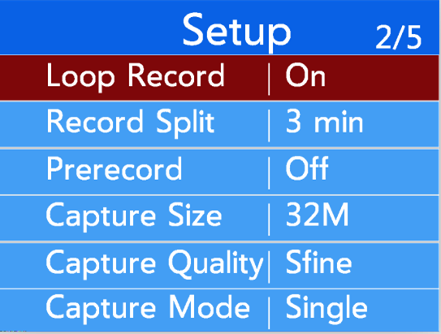
Recording segmentation
The video segment is divided into 3 minutes, 5 minutes, 10 minutes, 15 minutes, default 3 minutes.

Video prerecording
Video pre-recording enabled 15 seconds of pre-warning time.

Photo size
Photo size support 32M. 16M.12M. 8M. 4M

Photo quality
Photo quality support high, medium, low three options.

Photo mode
The camera mode is divided into single shot mode, the camera and the timing of continuous shooting mode.

Continuous number of photographs
The number of continuous support 5, 10, 15, 20, 25

Photo interval
Photo intervals support 3 seconds, 5 seconds, 10 seconds, 30 seconds and 60 seconds

Automatic closing screen
Auto-turn-off support option to turn off, 30 seconds / 1 minute / 3 min / 5 min.

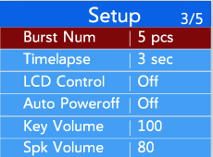
auto shut off
No video on the device.
And network transmission, the device automatically shuts down after the set time. You can
Select close 3 minutes for 5 minutes and 10 minutes for default.

Key volume

Key output volume adjustable

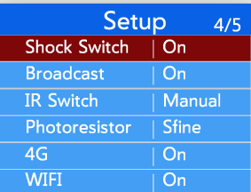
Loudspeaker volume
Horn output size adjustable

vibroswitch
Keystroke shake prompt can be turned on or off

Voice broadcast
Support voice broadcast on and off, when turned on, voice broadcast IDs, video prompts

Infrared switching
Infrared switching supports manual and automatic modes

Guang Min induction
Guang Min induction support high, medium, low choice, default high

4G switch
4G optional open and close, by default, the power consumption of the machine will be increased, and the working time of the device will be shortened.

WIFI switch
WIFI is optional to open and close, and after opening, you can choose to do STA mode or hot spot mode.

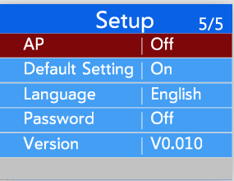
AP
After the AP is turned on, the machine will enter hot spot mode, and the WIFI needs to be turned on to open the hot spot.

Restoration of factory setting
Restore the factory setting to restore all parameters to the default value.

Language

The language currently supports switching between Chinese and English

Set the password

To open or close, enter the login password before setting up

system info
The system information is used to display the real-time working state of the device and peripheral equipment, mainly including the central connection state and the GPS state and the WiFi state.
4G dial status and device information.

Central information
Server information, including central IP and ports, as well as device numbers and online information.
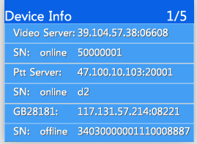

4G state
4G status is mainly related to the self-checking and dialing of 4G module, including whether the 4G module exists or not, whether the SIM card has 4G signal value, whether the dial-up is successful, and so on.
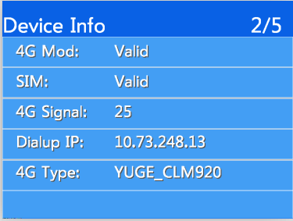

GPS state
The GPS state includes the existence of the GPS module, whether it is located, the number of satellites, and the latitude and longitude of the satellite.
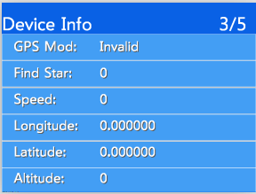

WIFI state
The WIFI state includes the existing state of the WIFI module, the signal strength of the hot name WiFi and the IPs after the successful connection.
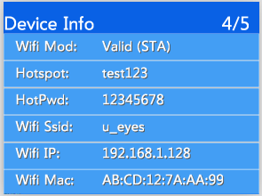

facility information
Device information is mainly used to display device version information and device unique IDs.
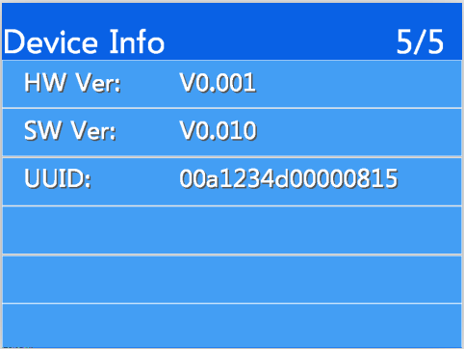

Product installation

3.1 container loading list

Order number | Name | Number quantity
1 | main engine | 1
2 | back splint | 1
3 | USB data line | 1
4 | The power adapter | 1
5 | instructions | 1
6 | certificate | 1
7 | Charging base | 1
8 | Charging base | 1

3.2 Equipment upgrade

First, the device is turned on and connected through the Body Camera tool. After logging in successfully, the device enters U disk mode.

Copy the upgrade files firmware_1201_dvr.ini and firmware_1201_dvr.bin to the TF card root directory;

Unload TF card unplug USB line, the equipment automatically restart and upgrade processing, the system will restart automatically after the upgrade is completed;

After a successful upgrade, you can see the new version of the software as a successful upgrade through the device's system information.

Upgrade as far as possible to ensure that the battery is fully powered or connected to the adapter.

Installation and use of Management Software for Body Camera

Software introduction

4.1 Software overview
The management software of the Body Camera (hereinafter referred to as the management software) is an application software developed by our company to cooperate with the high-definition Body Camera. It communicates with the Body Camera through the USB of the computer and realizes the user parameters. The acquisition and configuration management of video parameters, 4G parameters and WiFi parameters and central parameters. After logging in successfully, the device can enter U disk mode, and the playback and export of video data can be realized.
Software features:：
- Device logon logout management supports user password modification;
- It supports the acquisition and modification of the coding parameters.
- Time of synchronizing the Body Camera ;
- The acquisition and modification of user information;
- 4G acquisition and modification of network parameters such as WiFi;
- Acquisition and modification of video parameters;
- Acquisition and modification of central parameters;
- GB28181 center parameter acquisition and modification.

Software installation and operation
- First access to the software installation package by CD-ROM or mailKJTool_WIN_XXXXXXX.exe；
- Double-click to run or right-click to run the program as an administrator;
- Click next to complete the installation, the user can choose the installation directory during the installation process.
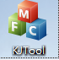
- Find the install software icon on the desktop or program startmenu, and double-click to run, as shown in the following figure:

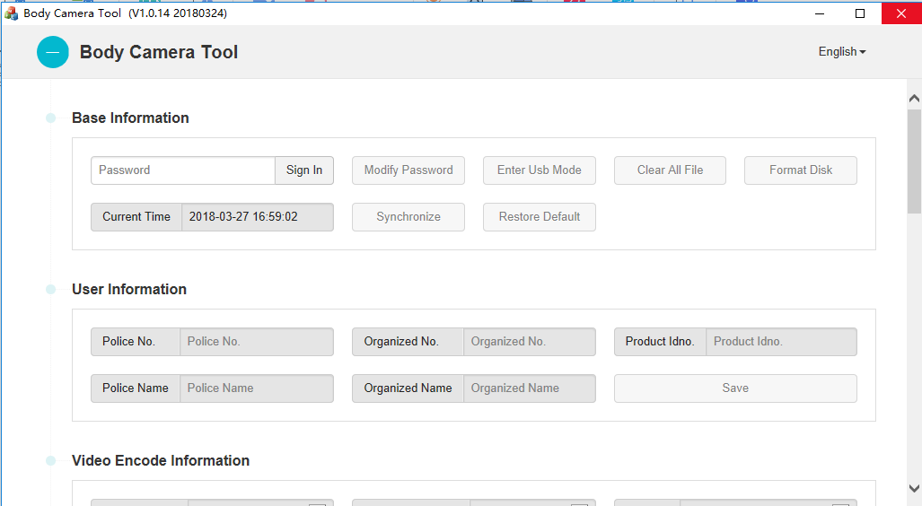

Software operations guide

essential information
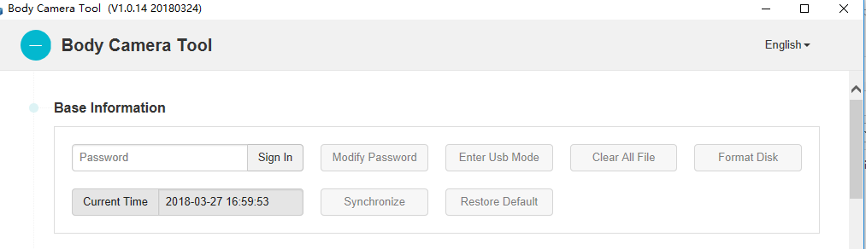
Note: first use the USB wire to connect the device to the computer.
Login: enter the password, click login, the default password is 000000;
Change password: click change password, the user can modify login password 6 for the number;
Enter the U disk: click into the U disk mode and click to determine the device for the U disk mode, you can find a new disk on the computer;
Clear all documents: clear all video files in the law enforcement instrument;
Formatted disk: format the disk of the law enforcement instrument;
Synchronous time: use computer time to calibrate the time of the law enforcement instrument;
Restore the default settings: restore the factory settings;

User information
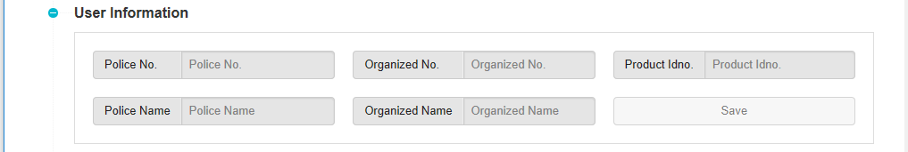
Alarm number: set up a Police Officer number;
Unit number: set user unit number;
Product serial number: set up product serial number;
Name: set user name;
Unit name: set up user unit name;

Codingparameter

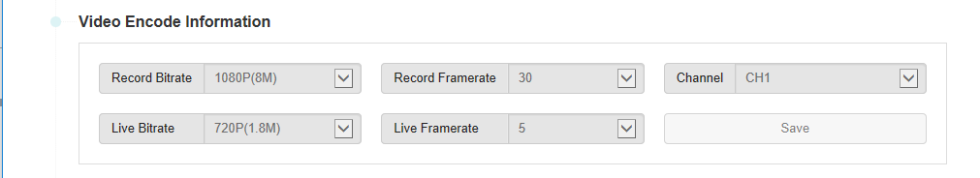

Video bit rate: select video resolution and bit rate, 1080P and 720P, and three bit rate optional;
Video frame rate: optional frame rate of 5: 10, 15, 20, 25, 30, etc.;
Choice of channels: only multiple channels can be selected;
Network transmission rate: select the resolution and bit rate for network transmission;
Network frame rate: select frame rate for network transmission;

4G parameter
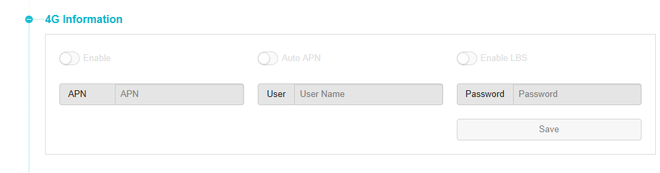
Enable : Turn on or off 4G functions ;
Automatic identification: set the access point information of the operator automatically;
APN: set up dial-up access point information, different operators have different names;
User: set up the user name for SIM card dialing, default is empty;
Password: set SIM card dial password, default is empty;

WIFI parameter:
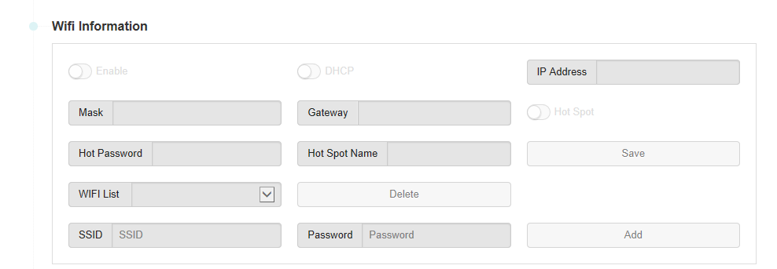
Enable: turn on or off the WIFI function;
Hotspots: WiFi works in AP mode, doing hot spots, the premise is to enable WiFi first;
Hot spot name: set the hot spot name, open the hot spot effective;
Hot spot password: set the hot spot access password, open the hot spot effective;
WIFI list: shows the WIFI hot spot name, the maximum support 8;
Delete button: select the hot spot name on the left, click to delete the corresponding hot spot;
SSID: sets the hot spot name to connect to;
Password: sets the key password to connect to;
Add button: add the hot information on the left to the device;

Central parameters
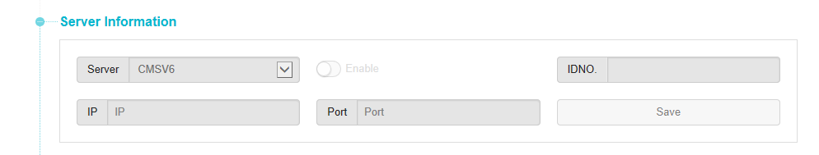
Enable: turn on or off the central server connection function;
Server: set the IPs of the server;
Port: set the connection port of the server;
Number: set the unique number of the device to report to the server;
；Save button: save parameter;

GB 28181 parameter

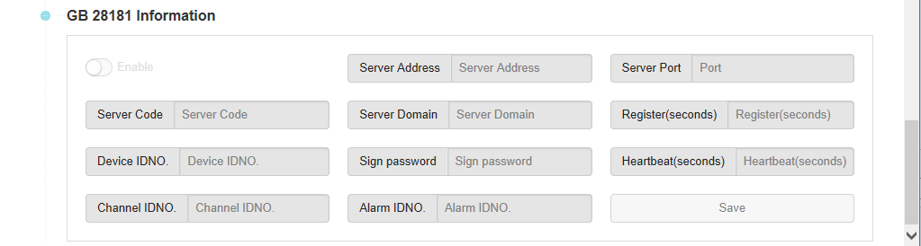

Enable: turn on or off the connection function of 28181 server;
Server address: set the connection IPs of the server;
Server port: set the connection port of the server;
Server number: set the reported server number;
Server domain name: set up server domain name;
The validity period of registration: setting the validity period of registration connection;
Equipment number: set the report number of the equipment;
Registration password: set up registration password;
Heartbeat cycle: set the reported heartbeat interval;
Channel number: set channel number;
Alarm number: set alarm number;
Save button: click the parameters of the save settings;

language selection
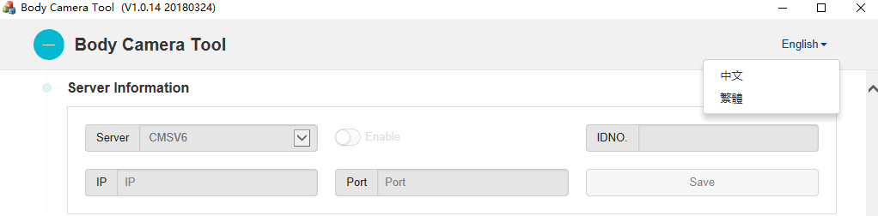
Click on the Chinese button in the upper right corner, pop up the options shown in the picture, choose according to the user's needs, currently support three languages: simplified Chinese, traditional Chinese, English, other languages need to be customized according to the needs of the customer.

5.9 Enter U disk mode
- First, enter the password to login, after successful login, click on "U disk mode" to enter the following figure:

- Click "login", the device enters the U disk and exits the login. The user can no longer configure the parameters, as shown in the following figure:

- On my computer you can see the U disk:

6.Use of attention

6.1 Unable to land

- First check whether the equipment is on normally;
- Check the connection of USB line;
- Pull off USB to reconnect ;

6.2 Parameter preservation problem
- Some parameter settings do not take effect immediately and you need to restart the machine to take effect;

6.3 Device restart
Unplugging the USB will automatically restart the device, and the settings will take effect immediately, and if it is not unplugged, the device will be recharged all the time.

